

Assisted natural regeneration in a tropical second growth forest in the Philippines as influenced by brush cutting and tillage
Adrian M. Tulod, Rechel M. Abanda

College of Forestry and Environmental Science, Central Mindanao University, University Town, Musuan, Bukidnon 8710, Philippines. Corresponding author: A. M. Tulod, amtulod@gmail.com

Abstract. The study was conducted to ascertain the restoration benefits of using assisted natural regeneration (ANR) technique to accelerate the recovery of second growth forest in the Philippines. Specifically, this examined the effectiveness of brush cutting and tillage as ANR treatments to enhance the growth rate, survival and diversity of woody regenerations. These treatments were conducted in the second and fourth month within a six-month period using 10 m x 10 m plots that were established in the direction that represented the forest structure and topography of the area. The ANR treatments did not indicate any positive influence on the height growth of regenerations and species diversity (species count), although brush cutting was found to have the highest population of woody regenerations and had higher species count than the other treatments. Regeneration in the control grew significantly faster than those with ANR treatments but this was not significantly different with those in the brush cutting treatment. Survival rate was significantly higher in the ANR treatments than in the control at the end of the study.
Key Words: ANR, restoration, Mindanao, natural regeneration, growth.

Introduction. Second growth forests are the largest and most dynamic natural forest ecosystem in the Philippines covering about 83% (5 million hectares) of the total forest area (Lasco et al 2001). They are the heavily exploited forest in the country since the implementation of logging ban in the primary forests in 1992 (Lasco et al 2001), but their natural recovery just like other tropical forest areas subjected to intensive anthropogenic activities are usually slow due to soil degradation, recurring disturbances, and isolation from intact forests (Shono et al 2007). Hence, the need to manage them to accelerate their recovery and restore productivity, biodiversity and other values is widely recognized (Parotta et al 1997).
Assisted natural regeneration (ANR) is considered one of the most viable methods to restore degraded tropical forestlands and transform them into more productive forests (Carandang et al 2007; Shono et al 2007). The aim of ANR is to accelerate the trajectory of natural successional processes by reducing or removing barriers to natural forest regeneration such as competition to available resources by weed species; recurring disturbances like grazing, fire and wood harvesting; and marginal soil condition (Shono et al 2007). According to Sajise (2003), ANR is most suited for areas where protection functions of forests is critical such as areas which are ecologically vulnerable, areas where conservation of biological diversity and soil and water are highly needed, among others. Unlike to the conventional restoration methods that involve planting of nursery grown seedlings, ANR is said to offer significant cost advantages due to reduced costs associated with seedling propagation and transplanting (Shono et al 2007). However, despite of its advantages, ANR techniques are still vastly under-appreciated and under-utilized in the Philippines (Ganz & Durst 2003) perhaps for lack of effective promotion, government support, and/or published quantitative data to support its effectiveness. Although Memorandum Circular NO. 17 to prioritize the application of ANR in the development of watersheds, protection and production forests in the Philippines has been issued by the Department of Environment and Natural Resources more than two decades ago (DENR 1989; cited by Carandang et al 2007), published data of ANR effectiveness and extent of its application in the country are still limited. Its continued implementation including documentation of restoration results and ecological requirements of natural regeneration should have provided opportunities to improve the application of ANR technology.
This study, therefore, hopes to provide inputs in understanding the regeneration dynamics of a second growth forest in response to application of ANR, while at the same time, contribute to the promotion of ANR techniques in the forest restoration programs in the country. Specifically, the study examined the effectiveness of brush cutting and tillage as ANR interventions in promoting or improving the growth and diversity of regenerations in a second growth forest.

Material and Method

Description of the study site. The study was conducted from October 2012 to February 2013 in a second growth forest in Musuan, Maramag, Bukidnon in the Island of Mindanao, Philippines (Figure 1).
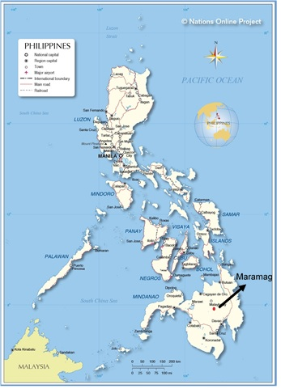
Figure 1. Location map of Maramag, Bukidnon in Mindanao, Philippines.
Map source: Nations online 2016.
The town of Maramag, Bukidnon lies within the geographic coordinates of 7º41’ to 7º58’N and 124º47’ to 125º14’ E (Province of Bukidnon 2015). The climate is classified as falling under type IV climate which is rainy from June to October and usually dry from February to April (Province of Bukidnon 2015). The study site is located on south-facing, gently rolling terrrain with an average elevation of 500 to 600 meter above sea level, which is way below than the average elevation of the province at 915 meter. The second growth forest in the study is a mix of native and exotic species perhaps due to its proximity to exotic tree plantations such as mahogany (Swietenia macrophylla) and teak (Tectona grandis). It covers an area of approximately five hectares with a flat to rolling terrain. Soil pH in the experimental sites is generally acidic ranging from 5.05 to 5.31 with a very low soil moisture content (%) of 28 to 36ºC. Organic matter content in the area, which is an indicator of available nitrogen status of soils, is generally low ranging from 2.81% to 3.94% only indicating poor condition of the soil with respect to available nitrogen.

Experimental design. The study involved three ANR treatments with three replications per treatment. The ANR treatments were brush cutting, tillage, and the control (no intervention). Brush cutting here involved cutting of grasses and vines to tree seedling height in the area while making sure that the existing woody species regeneration within the plot will not be cut or damaged. The tillage treatment, also known as cultivation, was carried out by manually removing all the grasses and vines (including their root systems) within at least 0.5 m radius around the stem of the marked seedlings including woody debris, stones and litter layers thus turning over of the soils in the process while giving the woody species in the plot enough space to germinate, establish and/or grow. The brushing and tillage were conducted in the second and fourth month within a six-month period. A total of nine sample plots measuring 10 m x 10 m were used in the study. Each plot of each treatment was established one meter away from each other and each replicate is located 10 meters apart in the direction that represented the forest structure and topography of the area.
All the regeneration (i.e. seedlings with ≤ 1.3m in height) found inside each plot were identified, counted and tagged. Representative samples for each species found was selected and numbered for monitoring of growth and survival. Th number of samples per species was determined arbitratry such that more samples were selected for species with more regeneration. Two measurements of height were employed: initial measurement and six months after the initial measurement. Height was measured from the ground up to the apical bud using a meter stick. To determine the influence of treatments on the number of species recruited or species count, all the woody species regeneration without tag and/or number within each plot at the final measurement were identified and counted.

Data manipulation and analysis. Data were averaged for each treatment in each replicate to facilitate the analysis. One-way ANOVA was used to determine significant effects of treatments on seedlings’ population, species count, relative height growth (RHG), and survivorship. Prior to ANOVA analysis, Barlett’s and Fligner-Killeen tests were used to check on the assumptions of normality and homogeneity of variances among treatment means. Data on survivorship was arcsine transformed prior to analysis. Post hoc pairwise comparisons of significance was carried out for one-way ANOVA using the glht function of the R Multcom package. Survivorship is the percentage of all tagged and numbered seedlings at the time of the experiment that were alive during the final measurement. The RHG is the height gain of all tagged and numberred seedlings over a six-month period calculated using the following equation:

RHG = H2 – H1/H2

where, H1 and H2 were the respective absolute seedling heights measured at the time of the experiment and six months later. Species count represent the number of species recruited at the end of the study period. All statistical analyses were undertaken using R (R Development Core Team [R] 2015).
Results and Discussion

Height growth. The initial and final (i.e. six months later) mean absolute height of woody regenerations differed significantly among treatments [(one-way ANOVA_{Initial_ht.} [F_{[2,6]} = 10.66, p-value = 0.0106]), (one-way ANOVA_{Final_ht.} [F_{[2,6]} = 9.537, p-value = 0.0137])] with the taller regenerations were generally observed in the tillage treatment (Figure 2A). Mean absolute heights of regenerations in the final measurement by treatment were: control = 28.75 cm (± 2.41); cutting or brush cutting = 34.14 cm (± 4.57); and tillage = 48.70 cm (± 2.60). These results, however, are still way below to the acceptable mean height standard of 1.5 m or even to the marginally acceptable mean height of 1.25–1.49 m, which could translate to a more than doubling of seedling height within 17 months (Elliot et al 2003). The ANR treatments were not observed to enhance the growth rate of regenerations as those in the control (0.04 ± 0.012 RHG) even grew faster than those in the cutting (0.01 ± 0.001 RHG, p-value = 0.0566) or tillage (0.005 ± 0.0008 RHG, p-value = 0.0229) treatment (Figure 2B).
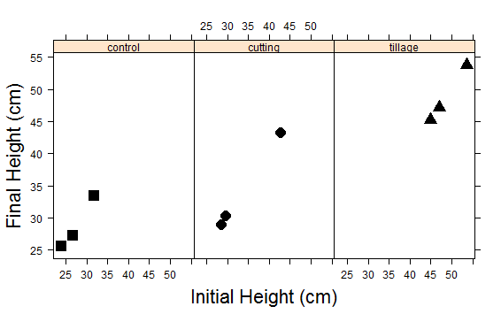

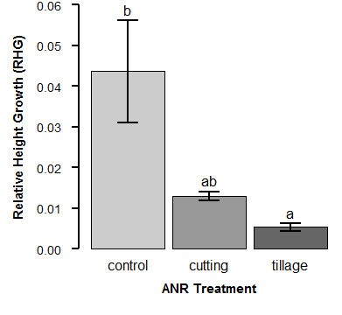
Figure 2A. Mean height of regeneration at the start of the experiment and six months after ANR treatments.
Figure 2B. Mean relative height growth of regeneration six months after ANR treatments. Bars with different letters indicate significant differences at 5% level of significance.
Error bars represent + 1 SE.

While this mean less labor inputs or cost-effectiveness to forest restoration as there is no need for management interventions to enhance the growth of regenerations; six months were probably too short to observe significant increase in the height growth of tree seedlings using cutting and tillage. Conversely, ANR treatment through cutting was observed in the study of Carandang et al (2007) to improve the height growth of regeneration 12 months after establishment of experimental plots in an Imperata dominated grassland. This kind of comparison, however, may be affected with the way ANR treatments were applied i.e. in terms of timing, frequency and method of their application. Cutting of grasses was done monthly in the study of Carandang et al (2007) but this could be more labor-intensive and expensive approach for large scale restoration. Nonetheless, an enhanced growth rate of regeneration is highly critical as this would mean faster recovery of the forest cover, or earlier closure of the forest canopy that in turn would lead to suppression of weeds (Carandang et al 2007) and the creation of cooler, shadier, moister conditions on the forest floor that is favorable for establishment of more forest tree seedlings (Elliot et al 2003).

Survivorship. Survival of regenerations differed significantly among treatments (one-way ANOVA [F_{[2,6]} =13.93, p-value = 0.006]) with both cutting and tillage providing 100% seedling survivorship than the control (90.33% ± 2.46) (Figure 3). The reduction of competition in the area from weed species as a result of cutting or tillage treatments was therefore beneficial given the marginal condition of the site in terms of moisture and nutrient resources. This enhanced survivorship can provide further merits to the application of ANR in heavily exploited or degraded second growth forest as higher survival rate of regeneration has the potential to bring the succession processes to a higher seral stage thus accelerating the re-assembly of forest structure and composition.
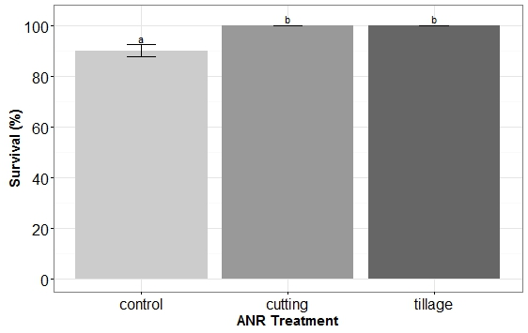
Conversely, such persistence of seedlings after ANR treatments may indicate the contrasting responses between pioneer and shade-tolerant species; and hence, suggesting further that only pioneer or gap species may benefit from ANR treatments, which bears negative implications to biodiversity conservation. However, Sajise (2003) noted that tropical forests have the natural tendency to revert back to a more diverse forest composition with climax or canopy species replacing the perennials and pioneer species in the process.
Figure 3. Mean percent survival of regeneration six months after ANR treatments. Bars with different letters indicate significant differences at 5% level of significance.
Error bars represent + 1 SE.

Number of regeneration. Significant differences were observed in the number of regenerations among ANR treatments (one-way ANOVA [F_{[2,6]} =13.93, p-value = 0.006]) (Figure 4) with the cutting treatment (43 ± 2 individuals) significantly receiving the highest population of woody regenerations six months after ANR applications as compared to the control (35 ± 2 individuals) and tillage (32 ± 1 individuals) treatments. The result was in contrast to the two year study of Carandang et al (2007) where the cutting or slashing application in a grassland ecosystem had the lowest number of regenerations suggesting different ANR requirements for different types of vegetation cover. The reduction of competition from the weedy species for soil moisture, nutrients and light while not disturbing the soil environment during brush cutting treatment in the study may have provided favorable conditions for existing seeds in the soil to germinate. The use of tillage, on the other hand, did not seem to provide significant influence on seedling recruitment as this was statistically tied with the control (p-value = 0.6322). The disturbance and undue exposure of the soil seed bank during the application of tillage may have caused dessication of the seeds in the soil as the soil moisture in the area were already marginal. This could probably one of the reasons why Shono et al (2007) suggested to implement the initial ANR treatments at the onset of rainy season so that seeds and seedlings will have the full growing season of accelerated germination and growth. However, one problem with this timing, is that it is in dry seasons that most seeds are dispersed, thus sufficient amount of water or soil moisture at seed dispersal time would be critical to facilitate natural regeneration in the study area. Kartawinata et al (2001) suggested the need to understand the niche requirements of natural forest tree seedlings to enhance the effectivenes of ANR treatments as each species may have different ecological preferences. Also, long-term monitoring to understand the dynamics and patterns of natural regeneration over time would be necessary in the formulation of a sound set of ANR prescriptions (Carandang et al 2007), thus reducing uncertainties associated with the nature of successional processes (Pardos et al 2005).
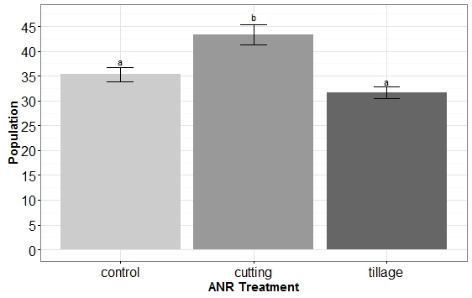
Figure 4. Mean population or number of regeneration six months after ANR treatments. Bars with different letters indicate significant differences at 5% level of significance.
Error bars represent + 1 SE.

Species count. ANR treatments did not favor significant number of species recruitment (one-way ANOVA [F_{[2,6]} = 3.267, p-value = 0.110]) (Figure 5), although the number of new species was higher in the cutting than in the control and tillage. Similar non-significant result with ANR applications was observed in the two-year study of Carandang et al (2007), with the highest number of species count however in their study was observed in the control. The low species count in the study despite of ANR treatments may suggests the need for enrichment planting should a more diverse forest ecosystem is the aim of restoration. Elliot et al (2013) pointed out that about 30 species would be needed at the start of restoration to catalyze biodiversity recovery in most tropical forest ecosystems. However, the improved survival in the study as a result of ANR applications can likewise catalyze regeneration of more tree species, thus imrpoving the diversity of plants in the area over time (Carandang et al 2007).
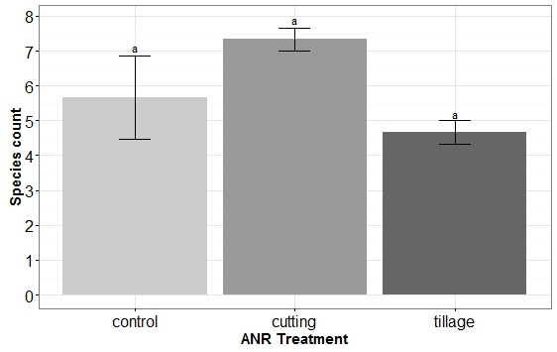
Figure 5. Mean species count of regeneration six months after ANR treatments.
Bars with different letters indicate significant differences at 5% level of significance.
Error bars represent + 1 SE.

Conclusions. The study has shown that ANR application did not have significant influence on height growth of woody regeneration suggesting that the six-month period may be too short to observe significant increase in the height growth of tree seedlings. However, ANR treatments were observed to increase the survival rates of seedlings that can provide merits to the application of ANR as data on survival has the potential to bring the succession proccesses to a higher seral stage and thus accelerating the re-assembly of forest structure and composition. Brush cutting was more effective in faciliting regeneration as it had the highest number of regeneration and number of species count as compared to control and tillage. The reduction of competition from the weedy species while not disturbing the soil environment during brush cutting treatment in the study may have provided favorable conditions for existing seeds in the soil to germinate and enhance the species recruitment.
Overall, while ANR application especially brush cutting has the potential to accelerate recovery of second growth forest in the Philippines, the need to understand the ecological requirements of forest tree species would be critical to facilitate the timing and frequency of ANR application. In the case of low species count following ANR treatments, enrichment planting may be prescribed as the rate of biodiversity recovery is said to increase with the number of species that can be re-instated at the start of restoration.

Acknowledgements. Special thanks to Central Mindanao University for the administrative support in the conduct of this study.

References

Carandang W. M., Paelmo R. F., Lee D. K., Carandang V. Q., 2007 Assisted natural regeneration as affected by lodging and slashing vegetation in a grassland in the Philippines. Forest Science and Technology 3(1):47-52.
Elliott S., Navakitbumrung P., Kuarak C., Zangkum S., Anusarnsunthorn V., Blakesley D., 2003 Selecting framework tree species for restoring seasonally dry tropical forests in northern Thailand based on field performance. Forest Ecology and Management 184(1):177-191.
Elliott S. D., Blakesley D., Hardwick K., 2013 Restoring tropical forests: a practical guide. Royal Botanic Gardens, Kew, 344 pp.

Ganz D. J., Durst P. B., 2003 Assisted natural regeneration: an overview. In: Advancing assisted natural regeneration (ANR) in Asia and the Pacific. Dugan P. C., Durst P. B., Ganz D. J., McKenzie P. J. (eds), Rap Publication 19, Food and Agriculture Organization of the United Nations Regional Office For Asia and the Pacific, Bangkok, Thailand, pp. 1-4.
Kartawinata K., Riswan S., Gintings A. N., Puspitojati T., 2001 An overview of post-extraction secondary forests in Indonesia. Journal of Tropical Forest Science 13(4):621-638.
Lasco R. D., Visco R. G., Pulhin J. M., 2001 Secondary forests in the Philippines: formation and transformation in the 20th century. Journal of Tropical Forest Science 13:652-670.
Nations online, 2016 Map of the Philippines. Available at: http://www.nationsonline.org/oneworld/map/philippines-political-map.htm. Accessed: August, 2016.
Pardos M., del Castillo J. R., Canellas I., Montero G., 2005 Ecophysiology of natural regeneration of forest stands in Spain. Investigación Agraria. Sistemas y Recursos Forestales 14(3):434-445.
Parrotta J. A., Turnbull J. W., Jones N., 1997 Catalyzing native forest regeneration on degraded tropical lands. Forest Ecology and Management 99(1):1-7.
Province of Bukidnon, 2015 General Information: Physical Feature and Composition. Available at: http://www.bukidnon.gov.ph/home/index.php/about-bukidnon/about-bukidnon/item/59-physical-feature-and-composition. Accessed: June, 2016.
R Development Core Team, 2015 R: a language and environment for statistical computing. R Foundation for Statistical Computing, Vienna, Austria.
Sajise P., 2003 Working with nature: technical and social dimensions of assisted natural regeneration. In: Advancing assisted natural regeneration (ANR) in Asia and the Pacific. Dugan P. C., Durst P. B., Ganz D. J., McKenzie P. J. (eds), Rap Publication 19, Food and Agriculture Organization of the United Nations Regional Office For Asia and the Pacific, Bangkok, Thailand, pp. 5-16.
Shono K., Cadaweng E. A., Durst P. B., 2007 Application of assisted natural regeneration to restore degraded tropical forestlands. Restoration Ecology 15(4):620-626.

Received: 07 August 2016. Accepted: 08 September 2016. Published online: 12 September 2016.
Authors:
Adrian M. Tulod, College of Forestry and Environmental Science, Central Mindanao University, University Town, Musuan, 8710 Bukidnon, Philippines, e-mail: amtulod@cmu.edu.ph; amtulod@gmail.com; adrian.tulod@pg.canterbury.ac.nz
Rechel M. Abanda, College of Forestry and Environmental Science, Central Mindanao University, University Town, Musuan, 8710 Bukidnon, Philippines, e-mail: r_abanda19@yahoo.com
This is an open-access article distributed under the terms of the Creative Commons Attribution License, which
permits unrestricted use, distribution and reproduction in any medium, provided the original author and source
are credited.
How to cite this article:
Tulod A. M., Abanda R. M., 2016 Assisted natural regeneration in a tropical second growth forest in the Philippines as influenced by brush cutting and tillage. AES Bioflux 8(3):265-272.

