Face Recognition with Pose and Illumination Variations Using new SVRDM Support Vector Machine

David Casasent and Chao Yuan
Dept. ECE, Carnegie Mellon Univ. Pittsburgh, PA 15213

ABSTRACT

Face recognition with both pose and illumination variations is considered. In addition, we consider the ability of the classifier to reject non-member or imposter face inputs; most prior work has not addressed this. A new SVRDM support vector representation and discrimination machine classifier is proposed and initial face recognition-rejection results are presented.
Key words: support vector machines, face recognition

1. INTRODUCTION

We consider face recognition with both pose and illumination variations present and with the need to reject non-member or imposter face inputs. A subset of the CMU-PIE (pose, illumination and expression) database [1] is used (Sect.3). To achieve both good recognition and rejection, a new support vector machine (SVRDM) is used. We recently [2] introduced this new SVRDM system, which we summarize in Sect.2. Our new face recognition results using it are presented in Sect.4.
The FERET database and tests on it have provided much valuable information on face recognition algorithm. However, this database does not include pose or illumination variations. Eigenfaces (view based) [3] have been used to handle pose variations (without illumination variations). Fisherfaces [4] have been noted to be of use for illumination variations, but only frontal pose variations were considered. Many graphics techniques [5-7] have been applied to the PIE and other databases with pose and illumination differences. The light fields method [5] uses 2D images to estimate the 4D light field. The method is computationally expensive on-line; it requires accurate registration and it assumes that a precise pose estimation is available. The illumination cone [6] method uses several different images to produce a 3D surface description of each person. Input faces are matched to the reference face whose illumination cone most closely matches. This method requires much storage. In other work, a morphable 3D face model [7] is produced using a 3D scanner. We assume only 2D sensors. Prior work noted that pose differences are a greater problem than illumination variations [8]. Our results support this.
We chose a support vector machine approach [9,10], since they offer a novel kernel solutions to higher-order classifiers. They also offer good generalization. However, they are not able to reject non-object data, or in the present case to reject imposter faces that are not client members [11-13]. Our support vector representation machine (SVRM in Sect.2.1 is motivated by providing good representation [11-13]. Throughout this work, we assume that there are no non-object class samples available for training. This is realistic for face recognition, where it is not realistic to have seen every possible imposter or non-client face. Similarly, in ATR, one cannot expect images of all possible other objects and clutter.

2. SUPPORT VECTOR REPRESENTATION AND DISCRIMINATION MACHINE (SVRDM)

In this section, we describe our new SVRDM classifier. For face recognition and other classification applications, it is vital that the classifier be able to reject non-member inputs. To achieve rejection and to handle true class variations, we first consider one class recognition and our support vector representation machine (SVRM) in Sect.2.1. To extend this concept to include multiple object classes, we present our SVRDM in Sect.2.2. Parameter choices for our SVRDM algorithm are addressed in Sect.2.3.

2.1 SUPPORT VECTOR REPRESENTATION MACHINE (SVRM)
Suppose there are two classes: C₁ is the object class and C₀ is the non-object class (non-member faces for this application). The task of one-class classification is to find the decision region R₁ for C₁ such that if the input x$∈$R₁, x is assigned to C₁; otherwise, it is rejected as C₀. Suppose that we are given N training vectors {x₁,x₂,…,x_{N}} from C₁. We assume that no training vectors from C₀ are available in this entire paper; others also make this assumption [11-12]. The training task is to find an evaluation function f₁(x), which gives the confidence of the input x being in the object class. We define the region R₁ ={x: f₁(x) ≥ T} to contain those object samples x giving evaluation function values above some threshold T. To achieve a high recognition rate, training vectors should produce high evaluation function values.
We borrow the kernel method used in support vector machines [9,10]. A mapping from the input space to a high-dimensional feature space is defined as $Φ:R→F$, where R is the input space and F is the transformed feature space. The explicit form of Φ and calculation of Φ(x) are not necessary. Rather, only the inner product Φ(x_{i})^{T} Φ(x_{j}) need be specified to be some kernel function. To evaluate Φ^{T}Φ, we simply evaluate the associated kernel function. We consider only the Gaussian kernel exp(-║x_{i}-x_{j}║²/2σ²), since it simplifies volume estimation and has other desirable properties. For a Gaussian kernel, the transformed training and test vectors lie on the unit sphere centered at the origin in F. Since the data are automatically normalized (to be of unit length), the distance between two vectors in F can be represented by their inner product. Thus, as our evaluation function, we use the inner product f₁(x)=h^{T}Φ(x), where h is a vector in F that we compute from the training set. It describes our SVRM and is used to determine the class of test inputs.
The h solution for our SVRM satisfies
$\left.\begin{matrix}\text{Min }{{\left\|h\right\|}^{2}}/2 \\ h^{T}Φ(x_{i})≥T=1,\text{ i}=\text{1,2,}\text{.}\text{.}\text{.},N\end{matrix} \right\}$. (1)
The second condition in (1) insures large evaluation function values for the training set greater than some threshold T (ideally equal to 1). We minimize the norm ║h║ of h in the first condition in (1) to reduce the volume of R₁ (to provide rejection of non-objects). We can show that a solution h with a lower norm provides a smaller class C₁ acceptance volume. In (1), we minimize the square of ║h║, since such optimization is easily achieved using quadratic programming. In practice, outliers (errors) are expected and we do not expect to satisfy the second constraint in (1) for all of the training set. Thus, slack variables ξ_{i} are introduced as in SVMs and h satisfies
$\left.\begin{matrix}\text{Min }\left\{{{\left\|h\right\|}^{2}}/2+C\sum_{i=1}^{N}{ξ_{i}}\right\} \\ h^{T}Φ(x_{i})≥T=1−ξ_{i},\text{ i}=\text{1,2,}\text{.}\text{.}\text{.},N \\ ξ_{i}≥0,\text{ i}=\text{1,2,}\text{.}\text{.}\text{.},N\end{matrix} \right\}$. (2)
This allows for classification errors by amounts ξ_{i} for various training set samples x_{i}. The factor C in the first condition is the weight of the penalty term for the slack variables. The solution h to (2) is a linear combination of the support vectors, which are a small portion of the entire training set. To classify an input x, we form the inner product h^{T}Φ(x); if this is some threshold T, we classify x as a member of the object class.
Fig.1 SVRM in the transformed feature space
Bounding boundary for SVRDM
Decision boundary
Bounding boundary for SVM
Fig.2. Conceptual SVRM(h_{SVRM}), SVRDM(h₁) and SVM(h_{SVM}) solutions in the normalized transformed space
Fig.1 shows a simple example in which the transformed samples z_{i}=Φ(x_{i}) lie on the unit sphere and the training set vectors cover the range from z₁ to z₃. Here, we use a 2D circle to represent the transformed feature space for simplicity. We use Fig.1 to show that an h solution with a lower norm (or energy) will recognize a smaller range of inputs and is thus expected to produce a lower P_{FA} (better rejection), The vector h shown crosses the unit circle midway between the end points of the training set data. Its length is such that the inner product h^{T}z_{i} is ≥1 for all z_{i}. The arc z₁z₃ in Fig.1 thus indicates the range of z that this h would accept (satisfying h^{T}z ≥ 1). The solution h/ shown in Fig.1 also satisfies h^{/T}z ≥ 1; but, the length (norm) of h/ is longer than that of h. This new h/ would result in accepting transformed data over the arc z₃/ to z₃, which is much larger than the extent of the original training set. Thus, use of h/ will lead to more false alarms (FAs) than use of h. Thus, an h with a lower norm is preferable.
In many circumstances, the training set is not adequate to represent the test set. Thus, in practice, we must use a threshold T < 1 in (1) and (2) and must use a decision region that is larger than that occupied by only the training data. However, we do not want this decision region to be too much larger or poor P_{FA} is expected.

2.2 SVRDM ALGORITHM
The SVRM is a one-class classifier that only involves one object class. We now extend the SVRM to the multiple-object-class case. This results in our SVRDM classifier. We consider K object classes with N_{k} training samples per class; the training vectors for class k are {x_{ki}}. We now consider classification and rejection. We define P_{C} as the classification rate, which is the percentage of the object class samples that are classified in the correct object class. P_{R} is the rejection rate, defined as the rate of object class samples rejected as the non-object class. P_{E} is the classification error rate, which is the rate of the object class samples classified in the wrong object classes. Thus, P_{C} + P_{R}+ P_{E} = 1. P_{FA} is the percentage of the non-object class samples (faces of imposter non-members) mistakenly classified as being in an object class. The objective is to obtain high P_{C} and a low P_{FA}. Our classifier approach is to obtain K functions h_{k}; each discriminates one of the K classes (k) from the other K – 1 classes. For a given test input x, we calculate the VIP (vector inner product) of Φ(x) with each h_{k}. If any of these kernel VIPs are T, x is assigned to the class producing the maximum VIP value, otherwise it is rejected. We assume that there are no non-object class samples in the training set. For simplicity, we first consider a two-object-class problem. For class 1 samples x_{1i}, we require the evaluation function VIP output h₁^{T}Φ(x_{1i}) ≥T and h₂^{T}Φ(x_{1i}) ≤ p. For class 2 samples x_{2j}, we require h₂^{T} Φ(x_{2j}) ≥ T and h₁^{T}Φ(x_{2j}) ≤ p. The parameter p is the maximum evaluation function value we accept for the other object-class samples. The two solution vectors (also referred to as SVRDFs, support vector representation and discrimination functions): h₁ and h₂ must thus satisfy
$\left.\begin{matrix}\text{Min }{{\left\|h_{1}\right\|}^{2}}/2 \\ h_{1}^{T}Φ(x_{1i})≥1,\text{ i}=1,2,\text{.}\text{.}\text{.},N_{1} \\ h_{1}^{T}Φ(x_{2j})≤p,\text{ j}=1,2,\text{.}\text{.}\text{.},N_{2}\end{matrix}\right\}$, (3) $\left.\begin{matrix}\text{Min }{{\left\|h_{2}\right\|}^{2}}/2 \\ h_{2}^{T}Φ(x_{2i})≥1,\text{ i}=1,2,\text{.}\text{.}\text{.},N_{1} \\ h_{2}^{T}Φ(x_{1j})≤p,\text{ j}=1,2,\text{.}\text{.}\text{.},N_{2}\end{matrix}\right\}$, (4)
Note that the VIP kernel function value for the object class to be discriminated against is specified to be p in this case. We typically have selected p in the range [–1, 0.6]. For this face database with all facial parts aligned, we used a much lower p=0.2 value. If we use p = – 1, then (3) and (4) describe the standard SVM. The classifier in (3) and (4) is our new SVRDM. The difference in the formulation of the SVRM and the SVRDM lies in the third condition in (3) and (4); this condition provides discrimination information between object classes by using p>−1 and use of p<−1 (the SVM solution is p=−1) and rejection of non-objects (imposter not-member faces). In the presence of outliers (training class errors), slack variables ξ_{i} are of course used in both h₁ and h₂. The final version for h₁ is thus
$\left.\begin{matrix}\text{Min}\left\{{{\left\|h_{1}\right\|}^{2}}/2+C(\sum{ξ_{1i}+\sum{ξ_{2j}}})\right\} \\ h_{1}^{T}Φ(x_{1i})≥1−ξ_{1i},\text{ i}=1,2,\text{.}\text{.}\text{.},N_{1} \\ h_{1}^{T}Φ(x_{2j})≤p+ξ_{2j},\text{ j}=1,2,\text{.}\text{.}\text{.},N_{2} \\ ξ_{1i}≥0,ξ_{2j}≥0,\end{matrix}\right\}$ (5)
and h₂ is similar.
To illustrate the difference between different SVM machines, Fig.2 conceptually shows several h vectors for class 1 and 2 training data noted in transformed space by filled-in and open circles. We show the conceptual solutions h_{SVRM} (for the SVRM), h₁ (for the SVRDM) and h_{SVM} (for the SVM). For simplicity, only 3 training data points are shown for each class; they denote the extremes of the training set and the average training set vector for each class. The SVRM solution for class 1 is the vector h_{SVRM} that passes through the average class 1 vector. The SVM solution h_{SVM} uses p = – 1. It is normal to the decision boundary, which is a vertical line through the center of the circle. For our new SVRDM with p = 0.6, the vector h₁ shown satisfies (3). The h₂ solution vector for class 2 in (4) is similar to h₁ but it lies in the first quadrant, symmetric about the vertical for this example. The lengths of the three vector solutions shown are proportional to their norms. We note that the energy of h_{SVM} is more than that of h₁ and h₂ which in turn are more than that of h_{SVRM}. These results are all expected. The range of transformed inputs that will be accepted into class 1 for the SVRDM are described by the arc z₃/–z₃ in Fig.2. This range is much less than the z₃// to z₃ range for the SVM. Thus, we expect a lower P_{FA} for our SVRDM vs. the SVM. If Fig.2 were a hyper-sphere, the bounding boundary for the SVM would be a hyper-circle on the surface of the hyper-sphere.
For an N-class problem, we form N pairs of SVRDFs. Each pair is intended to recognize one class vs. the rest, thus class 2 is the rest of the classes in the above 2 class example. For a given test input, if any evaluation function VIP gives a value above the threshold T, the input is classified to the associated class. If no evaluation function VIP gives an output above T, the test input is rejected as a non-object.

2.3 SVRDM PARAMETER SELECTION
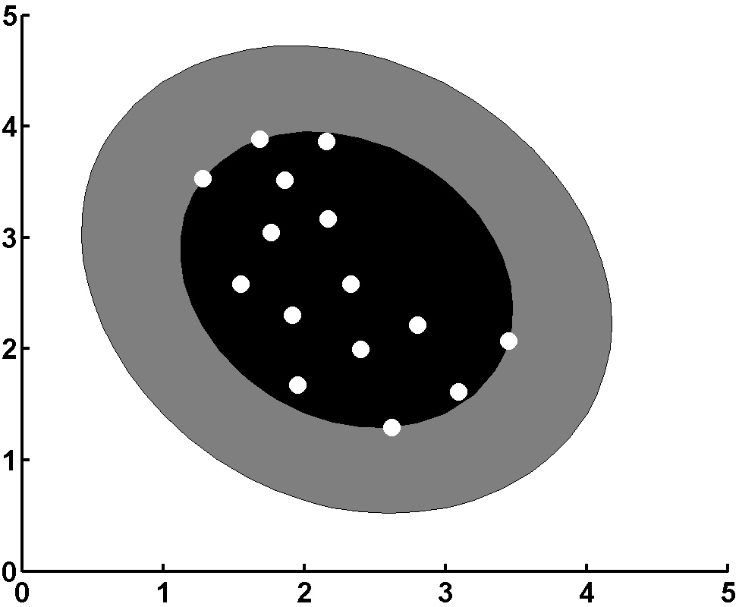
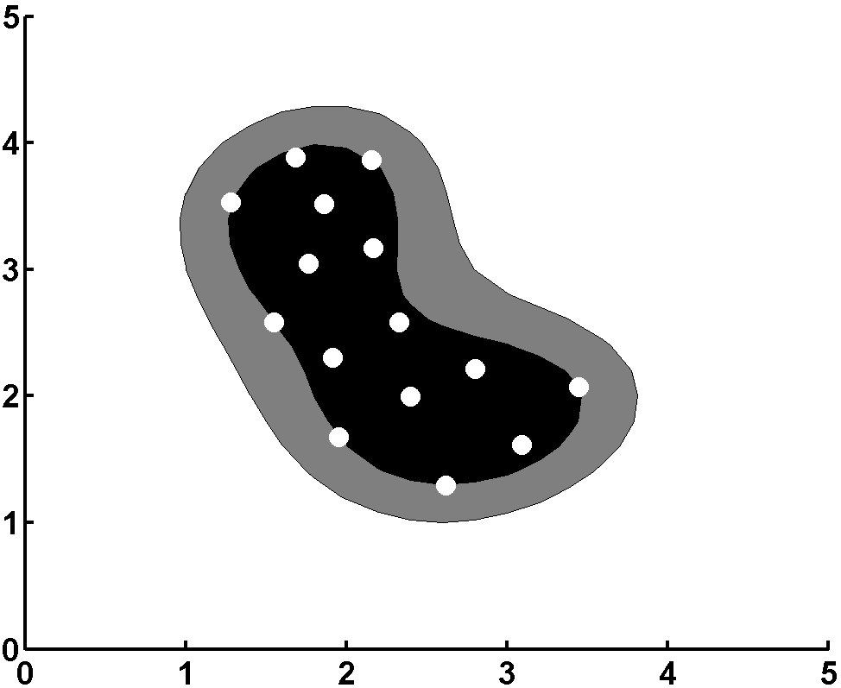
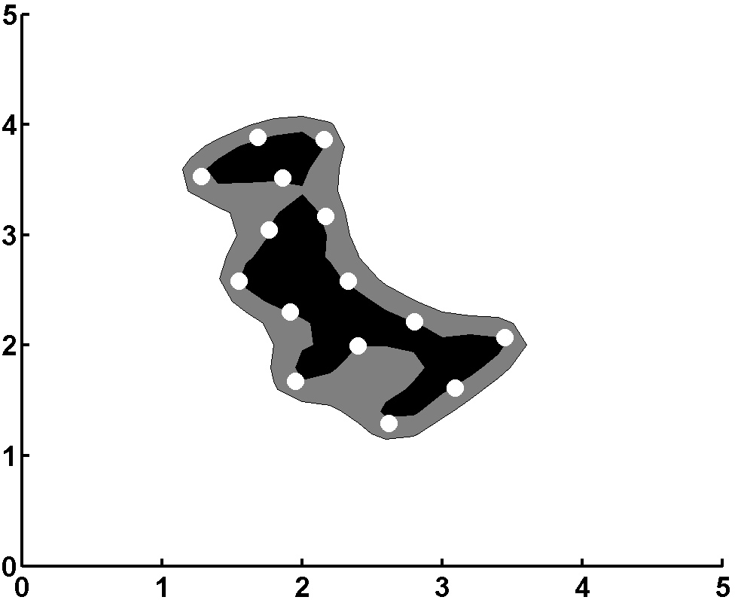
The SVRDM has several parameters to be chosen. In our work, we fixed C in (2) and (5) at 20, since we typically had few non-zero slack variables. In other cases, other C choices are preferable. For p, we have typically used p=0.6 for tests on synthetic data.
Fig.3 Bounding boundary and bounded region of the SVRM (a) σ=2.0 (b) σ=0.3 (c) σ=0.8
We now discuss selection of σ. We found performance to be significantly affected by the choice of σ in the Gaussian kernel function. For a one class case with 15 samples, Fig.3 shows how the region of space (in which samples will be called members of the object class) changes with σ. The dark region corresponds to the set of x value for which the VIP (vector inner product) h^{T}Φ(x) ≥ 1. We refer to this as the bounded region (BR). The outer extent of this region is the bounding boundary (BB). As seen, as we reduce σ, the bounded region shrinks and data in a smaller range of the input space is recognized as the object class. The data points on the boundary of the dark region are support vectors. For σ = 0.8, few (only 6 – 8) of the 15 samples are support vectors (Fig.3c). At the lowest σ = 0.3 choice (Fig.3b), all training samples are support vectors on the dark region boundary, and in this case we expect SVM concepts to be lost and test set performance to be poor. For larger σ choices (Fig.3a), the dark region is noticeably larger than for intermediate σ choices (Fig.3c). We thus expect that the σ = 2.0 choice in Fig.3a will yield more false alarms and poorer rejection. For the cases we consider, we expect to have to accept data in a region of space larger than that occupied by the training set data to achieve acceptable test set performance. The boundary of the lighter gray area in Fig.3 shows how much of the input space satisfies VIP output values h^{T}Φ(x) a lower threshold 0.8. As seen, larger σ values produce a proportionally larger area in the amount of space allocated to the object class. Thus, we expect the intermediate σ value (Fig.3c) to produce better acceptance and rejection results than a high value of σ (Fig.3a).
Prior work has used cross-validation to select σ [7]. We cannot use this since there are no non-object samples in the training set. The goal is to select σ to produce a tight bounding boundary around the N training samples. For a simple data distribution such as a single cluster as in Fig.3, we can easily choose σ to simply be d_{a}, the average distance of each training sample to the object class center (the mean of all the training samples) as in Fig.2c. However, much real data have distributions that have a complex shape and multiple clusters and in such cases selecting σ is difficult. The general idea in our algorithm is to first obtain an approximate bounding boundary for the object class. To do this, we compute N local SVRMs, since we can easily choose σ for each of these. Each local SVRM has its own local bounding boundary. We analyze these to obtain a set of sample vectors {v} that lie on an approximate boundary for all of the data. In step 2, we compute an SVRM for all of the training data using different σ values. Each will produce a different bounding boundary and a different set of training vectors {w} will lie on each boundary. The σ choice for which the set of training vectors {w} and {v} best matches is the σ value we use. We recently [2] detailed this algorithm.
Fig.4 shows a two-class example in the 2D input space rather than in the unit-sphere normalized transformed space in Fig.1. There are 15 training vectors for each class (solid and open circles). Figs.4a to d show the results for the 3 different machines as p is varied. The bounded region for which the VIP ≥ 1 for each case is shown by the dark gray region. The decision boundary for which the two VIPs are equal (h₁^{T}Φ(x) = h₂^{T}Φ(x)) is shown by the dotted line. As seen in Fig.4a, some class 1 samples lie on the wrong side of the decision boundary and represent errors for the SVRM; this is expected since the SVRM is not designed to provide two-class discrimination. The other three support vector classifiers in Figs.4b to 4d produce good and similar decision boundaries. We thus expect the SVRDM and the SVM to have similar discrimination capabilities. The SVRM produces the smallest dark gray bounded region in which objects are expected to be classified with high confidence. This region for the SVRDM fits the data well and its extent is much less than that produced by the SVM (Fig.4b). As we vary p, we control the characteristics of the classifier (its acceptance and rejection range). With a larger dark gray bounded region of acceptance, we expect the SVM to yield more false alarms than the SVRDM and that both classifiers will produce similar discrimination performance (determined by the decision boundary). The p = 0.2 to 0.6 choices result in a smaller dark gray bounded region than does p=-1 for the SVM.. The distribution of non-object to be rejected will determine the best p choice. If non-object lie near the decision boundary between classes, then a lower p value is needed. We expect to reduce the threshold T below one for our applications, as noted earlier; this is expected since very likely that test data will be distributed near the training set data, but will lie outside the dark gray bounded region. The light gray regions in Fig.4 indicate the outer bounds of the regions of the 2D input space for which the kernel VIPs are 0.8. As we gradually reduce T, the decision region will become larger. Since the bounded region for the SVRDM better fits the distribution of the training data, we expect better P_{FA} vs. P_{C} results.
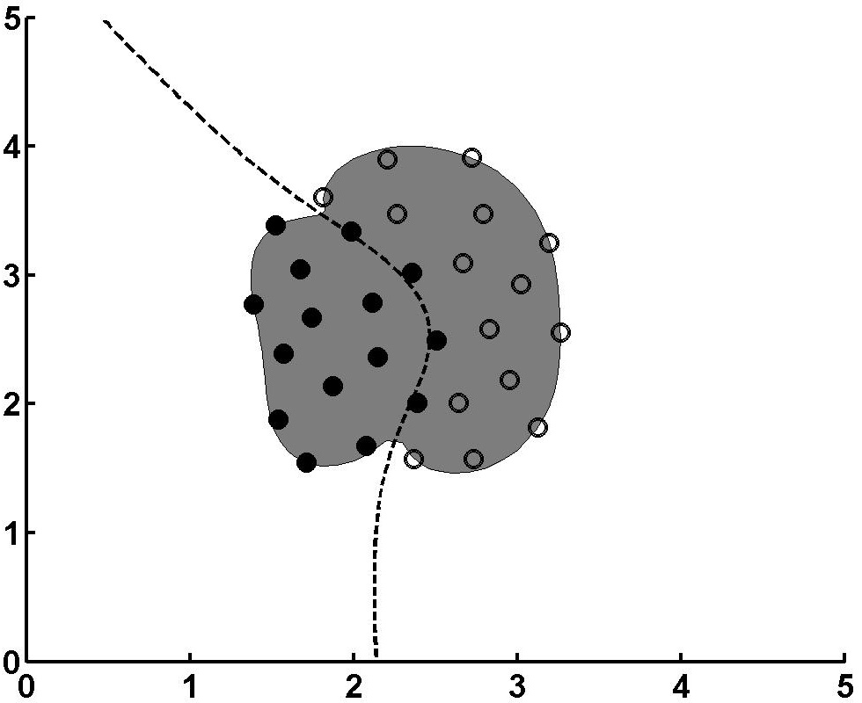
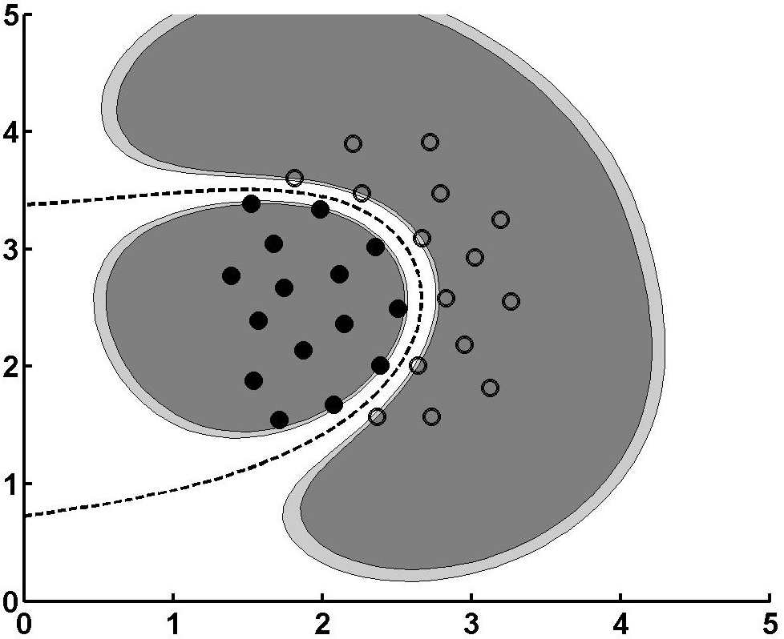
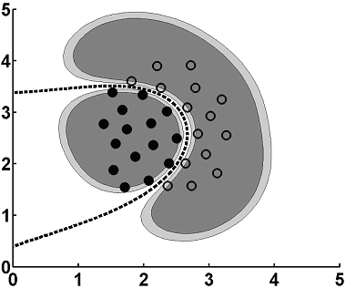
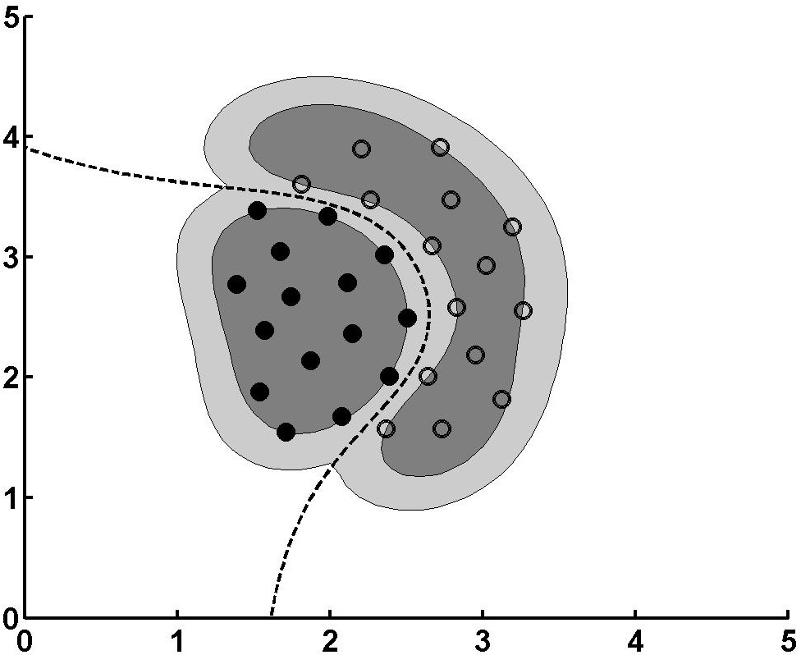
Fig.4 Bounding boundary, bounded region and decision boundary of the (a) SVRM, (b) SVM, (c) SVRDM (p = 0.2) and (d) SVRDM (p=0.6)
3. DATABASE AND SCORING

3.1 PIE FACE DATABASE
The subset of the PIE database [1] that we use consists of 21 illumination variations for each of 13 pose variations for each of 65 subjects. There are thus a total of 17,745 face or 273 images per person. Fig.5 shows the 13 pose views and the pose numbers we use for one subject. The arrangement follows the camera view; poses 1 to 9 vary in aspect angle from left to right pose, poses 10 and 11 are frontal at different elevation angles and poses 12 and 13 are at different elevation angle in corners of the room as in surveillance camera views. The 21 different illuminations are shown in Fig.6. The images we use are 60×48 pixels, with resolution reduced by averaging adjacent pixels in the original 640×486 pixel image by linear interpolation.

3.2 TRAINING AND TEST SETS
Our training set consists of nine pose variations (aspect view poses 1−9) and four illuminations (2, 15, 18, 20) for each. The remaining four poses (elevation angle differences) and 17 illuminations for each face are the typical test set. There are thus typically 9×4=36 training images per person and 4×17=68 test images per person. We use 25 of the persons as a non-object (imposter, non-client) database of faces to be rejected and include all 21×13=273 images of each of these persons (6825 images) in our non-object test reject classes. We varied the number of persons in the object class from 10 to 40.

3.3 REGISTRATION PREPROCESSING
All pose and illumination variation images for each person at a given pose were taken over a very short 0.7 second time interval, during which there is basically no head subject movement. A number of subjects have their heads tilted (in all images), e.g. Fig.7a. If such tilted images of this and other subjects were used in training and recognition, biased
results with higher P_{C} scores would result with recognition based on the subject’s tilt angle in addition to his facial features. Thus, to provide unbiased testing, we use a registered (aligned) training set of images of all faces. This registration was also used in previous work on this database [5, 6, 8]. We refer to this as face registration. For each facial pose, we locate the positions of several face landmarks (the eyes and mouth center and for the four feature case, the tip of the nose). We note that we found that the location accuracy of the last nose tip feature is poor. These spatial features are presently located manually, although methods to locate eyes [14] and other [15] facial features have been proposed. For each pose, we normalize all training set images to have the same eye spacing, and eye, nose and mouth positions. For each pose, the eye separation is different for a different pose, but the vertical location of the eyes, mouth, etc are the same for all cases. This removes the tilt bias. However, it makes all images more similar and thus makes discrimination and rejection more difficult.
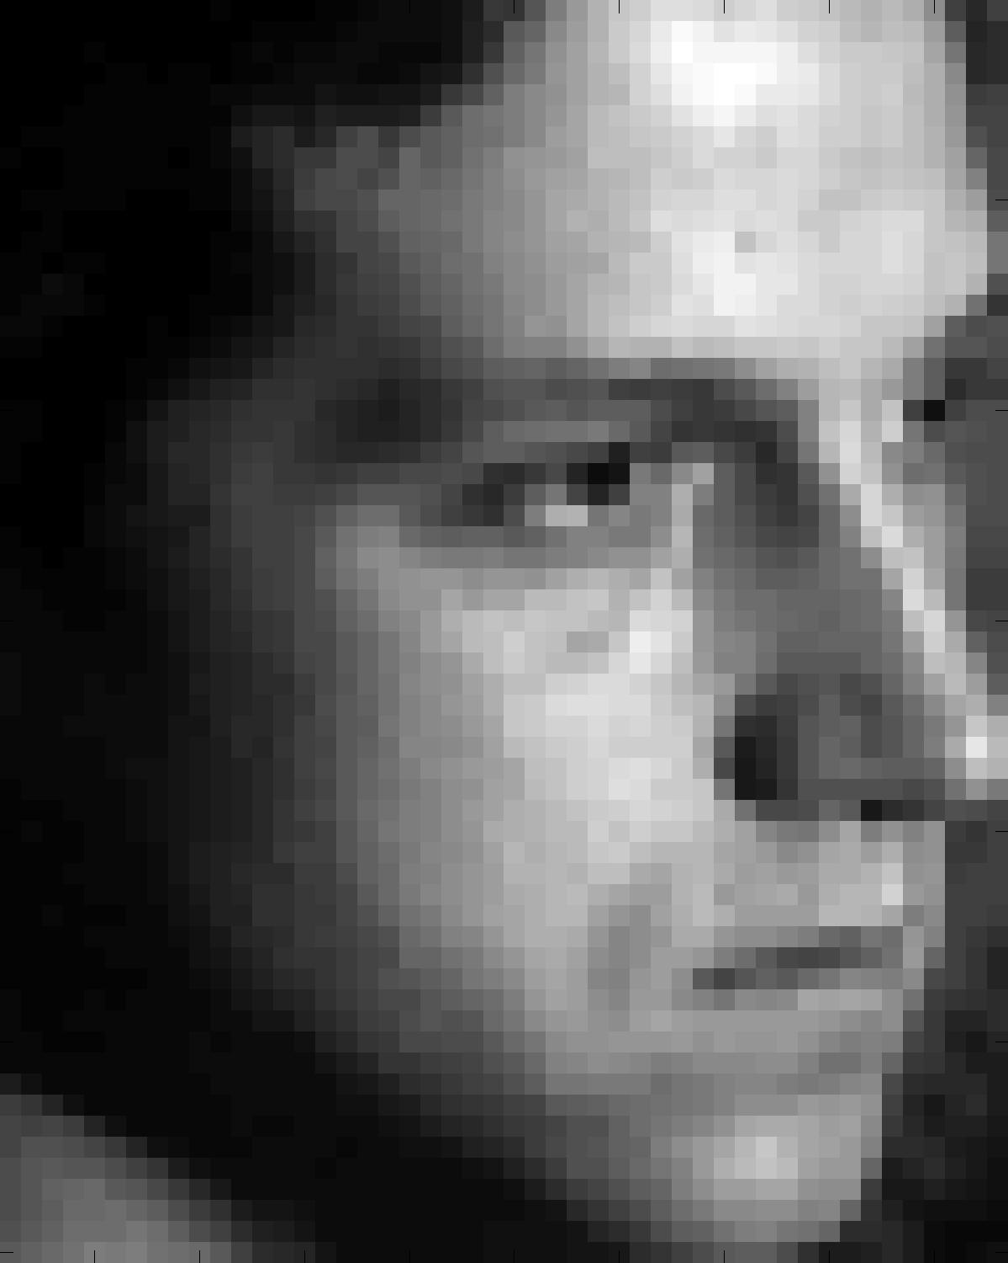
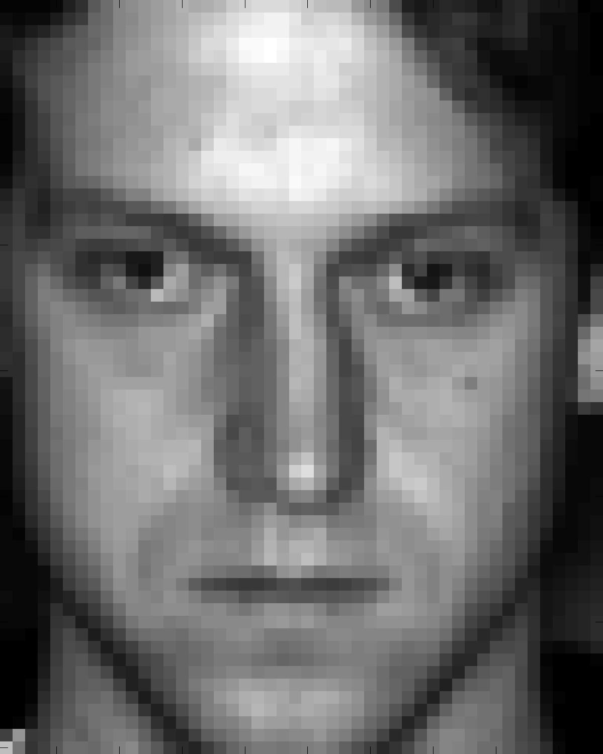
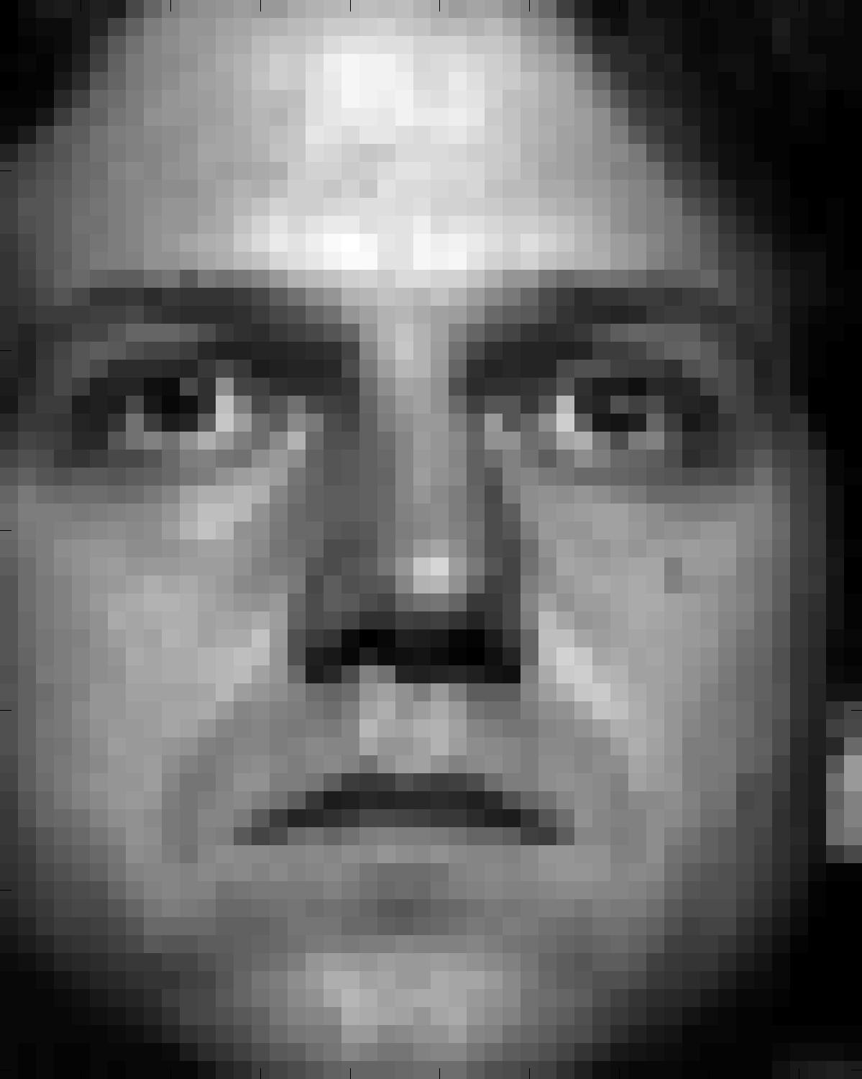
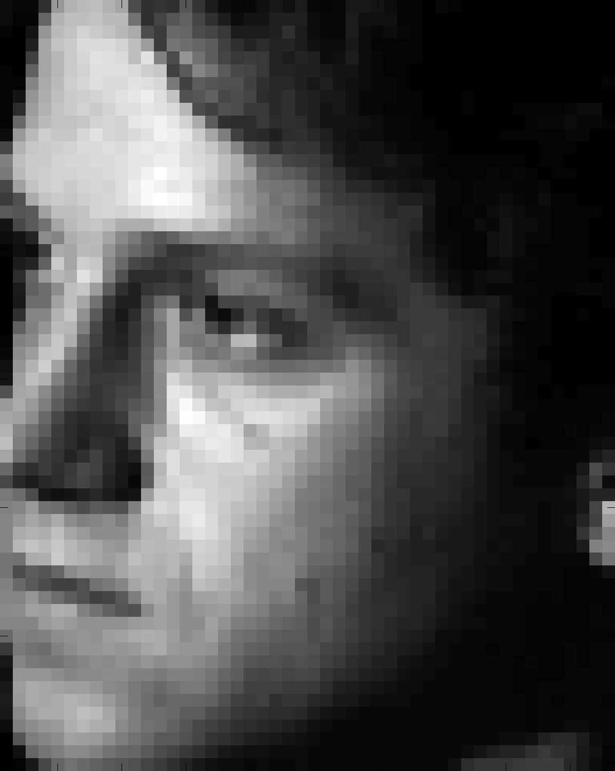
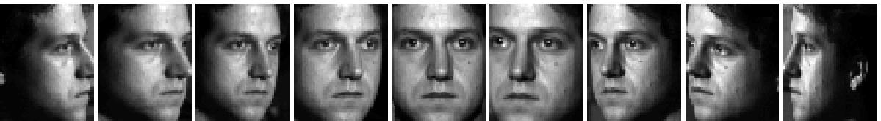
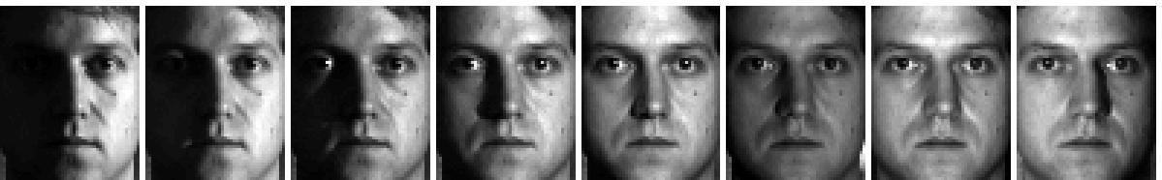
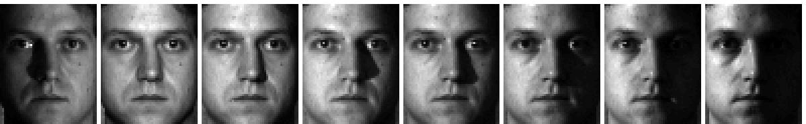
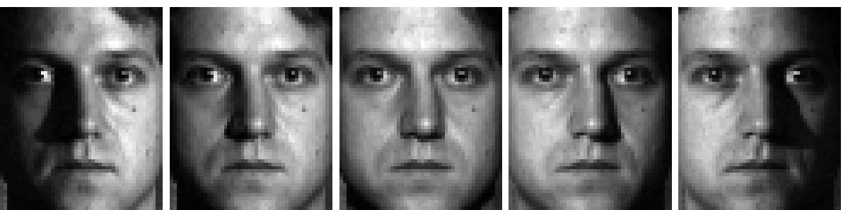
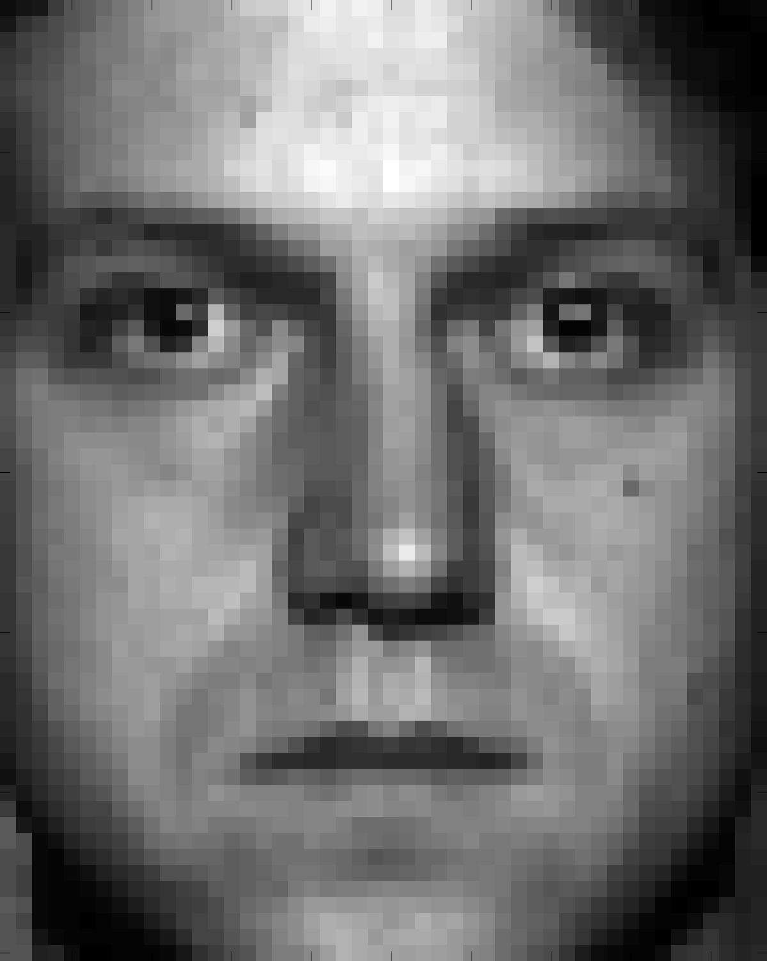


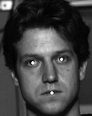

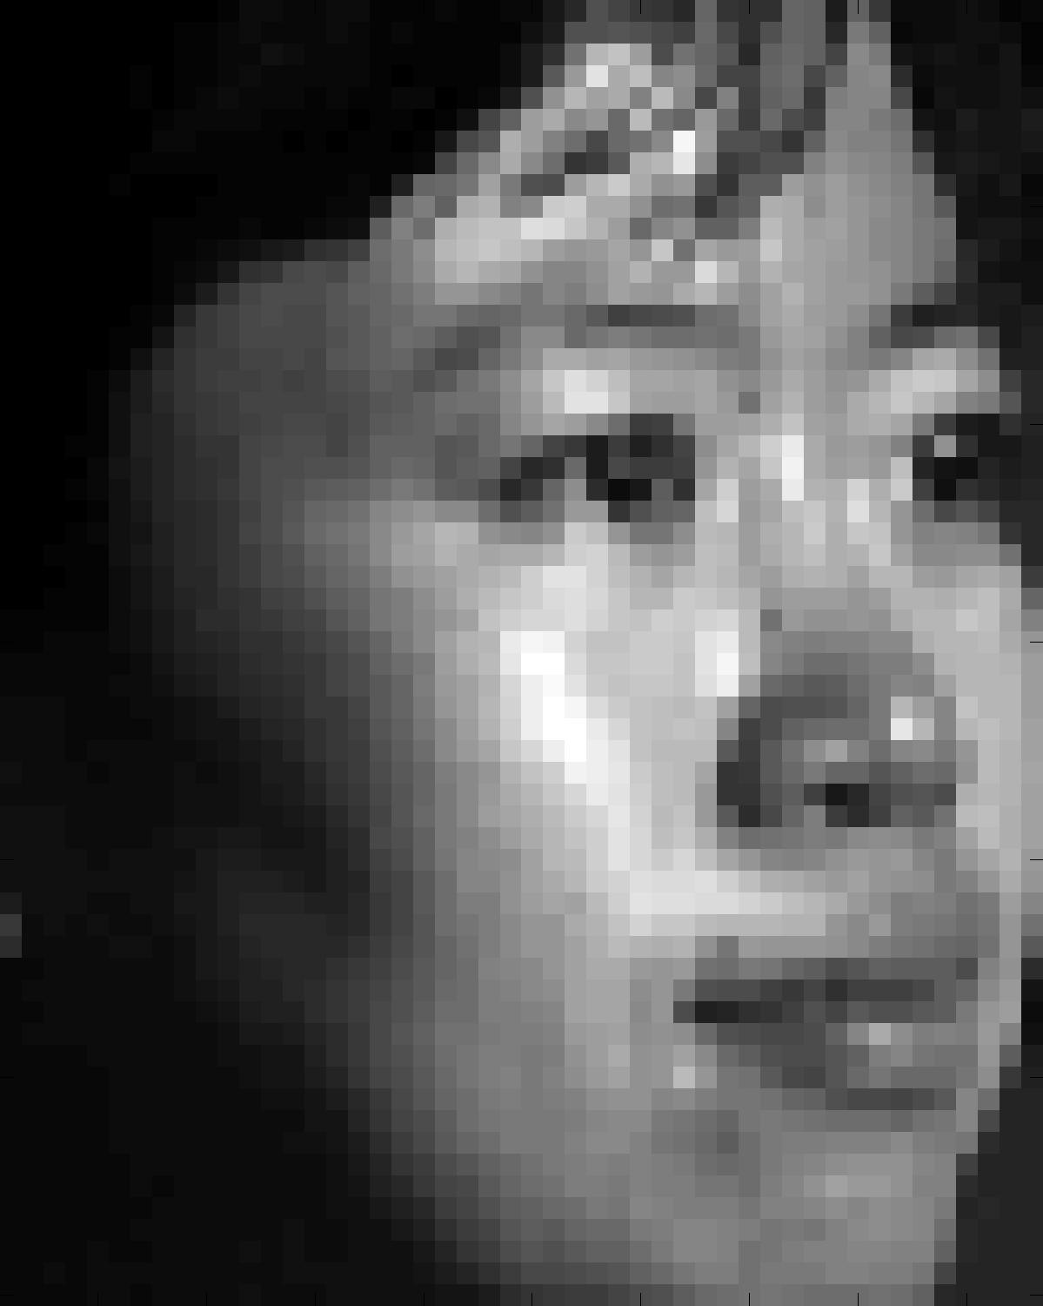
We now detail how to select the normalized locations of the facial landmarks for each pose. Fig.7f shows the original image (before registration) at pose 2 for the person used to select the facial landmark normalized locations for each pose. The subject chosen for each pose was one whose head was not noticeably titled in the head-on frontal-view image (pose 5). Since pose 2 and pose 8 are symmetric, we desire that the normalized locations of the landmarks in the pose 2 and pose 8 images are also symmetric. However, this symmetry is typically not true in original images. The 2 eyes have different vertical distances in pose 2 and pose 8. Similarly the distance of the eyes, nose and mouth from the edge of the image is different in the true images (the head is not usually centered and is slightly titled). To shift the reference locations of the facial landmarks, we shifted the locations of the eyes vertically and horizontally (so that symmetric eyes, e.g the left eye in pose 2 and the right eye in pose 8 lie on the same vertical row, and so that they are the same distance from the edge of the face and so that they are the same distance apart in the symmetric images). We shifted the locations of the nose and mouth horizontally and vertically similarly. The shifts of all landmark locations are typically only 1-2 pixels horizontally and vertically. This was done for each symmetric pair of poses and for the frontal pose 5 for our 9 standard poses 1-9.
Fig.5 Sample registered images showing pose variations.
17 18 19 20 21
9 10 11 12 13 14 15 16
1 2 3 4 5 6 7 8
Fig.6 Sample registered images showing 21 illumination conditions

Fig.7 Face registration; original (a) and transformed (b) example. Profile example: original (c), transformed using eyes and mouth landmarks (d); and distorted image using eyes and nose tip landmarks (e). (f) the original image at pose 2 for the person used to select the normalized facial landmark locations.

For the entire training set, we performed this image registration separately for each pose. This was done using affine transforms. These affine transforms are preferable as they handle the more complex realistic cases beyond simple object rotations and scales [16]. We locate the eyes and the center of the mouth (see white dots in Fig.7a). Our affine transforms are expressed by
$\left[\begin{matrix}x^{'} \\ y^{'}\end{matrix}\right]=\left[\begin{matrix}a_{\text{11}} & a_{\text{12}} & a_{\text{13}} \\ a_{\text{21}} & a_{\text{22}} & a\end{matrix}\right]\left[\begin{matrix}x \\ y \\ 1\end{matrix}\right]$, (6)
where [x/, y/]^{T} is the transformed point and [x, y]^{T} is the point before the transform. a_{ij} (i=1,2 and j=1,2,3) are the components of the affine transform matrix and are estimated using training set data to minimize MSE (mean squared error).
We retain the face from the forehead to the chin (see Fig.7b). Fig.7b shows the registered version of Fig.7a with the tilt removed. Fig.7c shows a half-profile image and its registered version using the eyes and mouth center as transform feature points. If the eyes and tip of the nose are used and the position of the nose tip is fixed in the registered image, then poorer distorted registered images such as Fig.7e can result. This is attributed to the large variations present in the length and size of noses and in the accuracy with which the nose tip can be located. Fixing the location of the nose tip in the registered image thus often distorts the lower part of the face.

4. FACE RECOGNITION TEST RESULTS

4.1 ONE-STEP INTERPOLATION AND EXTRAPOLATION FACE CLASSIFICATION
In our prior work [2], we used ten faces as our object classes and ten others as the non-object class to be rejected, eight approximately evenly-spaced illuminations were included in the training set and the remaining 21−8=13 illuminations were included in the test set. Pose variations are much more of a challenge than illumination variations [8]. In our interpolation experiment, five alternate poses among the central nine (poses 1, 3, 5, 7, 9) were used as the training set and the other eight poses as the test set. There are thus 8×5=40 training images per face and 233 test images per face. For the non-object class test faces, there were 21×13=273 images per faces. For the SVRDM, we set σ =2000 using our new algorithm (Sect.2.3). For the SVM, we set σ =1800. We compared our results to those using Eigenface [3] and Fisherface [4] methods. For the Eigenface method, we used a total of 80 eigenvectors; and for the Fisherface method, we used K-1 Fisher vectors (for K =10 classes). Each Fisher vector considers one true face class vs. all of the other classes. We use the covariance matrix (we subtract the mean of all images), thus the rank of the numerator in Fisher is K-1, not K. We project the test input onto these K-1=9 vectors and classify the test input using a nearest-neighbor classifier. A nearest-neighbor classifier was used for both the Eigenface and Fisherface features. Fig.8a shows ROC (receiver operating characteristic) results. P_{C} is the fraction of the test set object class samples correctly classified. P_{FA} is the fraction of the non-object samples not rejected (errors). In the extrapolation tests, poses 1-5 from only one side were used in the training set, and the illumination training set was unchanged. For the SVRDM, σ =2000 was used and σ =1750 for the SVM. Fig.8b shows ROC results. The EER for the SVM and the SVRDM are 29% and 37%, respectively (equal error rate (EER) is the ROC point in the top left where P_{E}=1−P_{C}=P_{FA}). The threshold T was varied to produce the Fig.8 ROC results.
In both ROC cases in Fig.8, the SVRDM performs best, followed by the SVM. The SVM required 151 support vectors per person, while the SVRDM needed only 95. Thus, the on-line computation requirements for the SVRDM are much less than for the SVM. In Table 1, we list the highest P_{C} performance P_{HC}, ignoring rejection performance. This is not our main concern here, but it is interesting to note that P_{HC} for the SVM and SVRDM are comparable and better than P_{HC} for both the Eigenface and Fisherface classifiers. We also note that performance is better for interpolation (when only intermediate poses are missing) than for extrapolation. We also note that the Fisher classifier is better than the Eigen one (as claimed in [4]) only in the interpolation case.
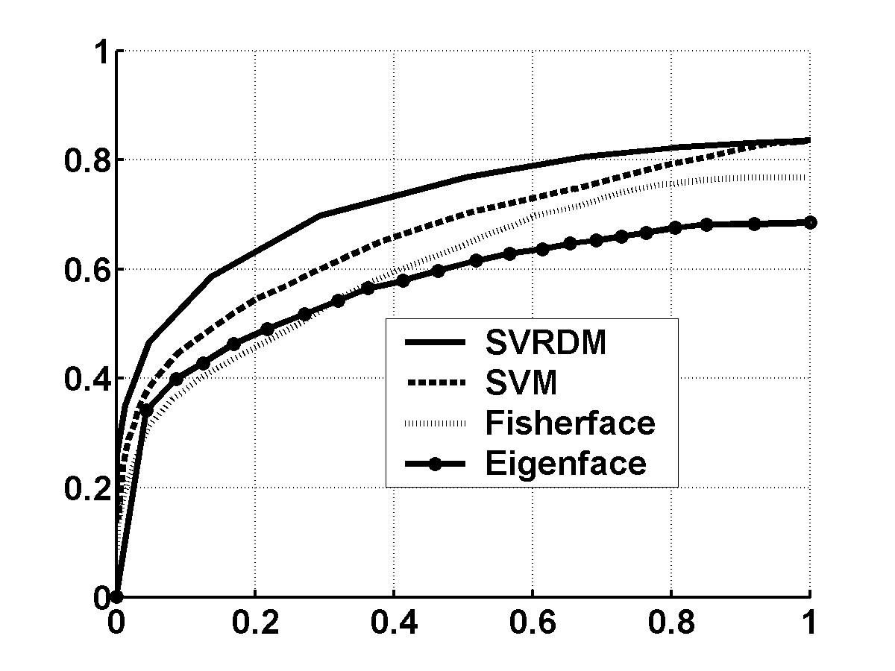
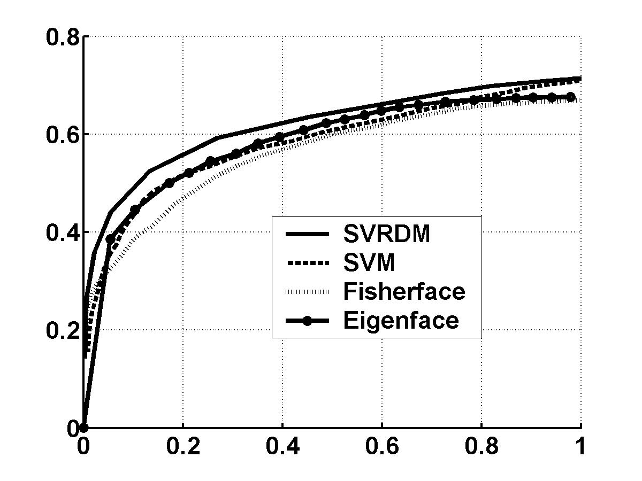
Fig.8 Experiments on PIE database. P_{FA} vs. P_{C} curves for (a) the interpolation test and (b) the extrapolation test for the one-step method

P_{C} | Eigen | Fisher | SVM | SVRDM
interpolation | 0.685 | 0.767 | 0.836 | 0.835
extrapolation | 0.676 | 0.669 | 0.708 | 0.713
Table 1. Highest P_{C} performance for the one-step method

To obtain good performance on the 40 class face recognition case with 25 non-object faces to be rejected, we only consider interpolation and we increased the number of pose views in the training set to include poses 1-9 (only poses 10-13 with a different elevation angle are now in the test set). Since illumination difference are more easily handled, we train on only illuminations 2, 15, 18 and 20, with the other 17 illumination being the test set. There are thus 9×4=36 training set images for each of the 40 faces and 273−36=237 test set images for each face. For the 25 faces to be rejected, there are 273 versions of each. We refer to these as our one-step training and test sets. The SVRDM performed best with EER=0.216 and P_{HC}=87.2%. The SVM performed worse and the other classifiers were even poorer. Most errors were due to pose variations.

4.2 TWO-STEP FACE CLASSIFICATION
To improve results, we consider a two-step algorithm. In step 1, we estimate the pose of the input face; and in step 2, we estimate the class of the input face. In step 1, there are nine classes (each is one of the training set poses 1-9). The same four illuminations (2,15,18,20) were used in the training set. We consider only the SVRDM for step 1. We produced nine SVRDFs; each was one class (one pose) vs. the other eight and each used all nine (poses) × four (illuminations)×K (object classes) = 36K training set images (we varied K and kept 25 faces to be rejected). In step 1, pose estimation, the inner products of the test input and the set of support vectors were separately calculated for each SVRDF and a set of evaluation function values were obtained. The largest evaluation function value determines the class (pose) of the input. In step 1, there is no threshold T for rejection and the best pose estimate is accepted. The test set consists of poses 10-13 at all illuminations and poses 1-9 at 17 illuminations for K faces, plus 273 versions of the 25 faces to be rejected. Pose estimation (step 1) actually contains 2 steps of classifiers. This was necessary because the input test data could not be registered without having a pose estimate and an accurate pose estimate required registered test set data. In stage 1 of pose estimation, we used the locations of four facial landmarks (2 eyes, nose and mouth) as the features for our stage 1 SVRDM. These facial landmarks can be automatically located [14, 15]. The SVRDF evaluation functions with the largest 3 values were retained (i.e. we retained the 3 top pose estimates, since the top pose estimate was often not correct). All data in stage 1 were not registered. The input test face was then transformed and registered to each of the top 3 pose estimates from stage 1 and these 3 registered faces were then fed to the stage 2 pose estimator. The stage 2 pose estimator in step 1 has a set of 9 SVRDF functions, one for each pose. It uses registered training set images and iconic features. The largest evaluation function output determines which of the top 3 pose estimates from stage 1 is the final pose estimate used. In both step 1 pose estimation classifiers, no rejection considered, as we desire an estimate of the pose of the input, rejection is addressed in our step 2 classifier. This transformed and registered input test face and its pose estimate is fed to the step 2 classifier.
In step 2, there are 9 classifiers, one for each pose and each is trained only on objects at the given pose. Each has K SVRDFs, one per class; each is intended to recognize one class and discriminate it vs. all K-1 other face classes. Classes are now a person’s face at a given pose. For a given pose, the set of K person (face) functions are evaluated, the largest ≥T determines the face class. If no output is ≥T, that test input is rejected as a non-object (in this case an imposter, a person not to be admitted).
We expect better performance from this two-step classifier, since each classifier is now simpler. For the step 2 classifier, we compare 4 different classifiers. Recall that there are two stages in step 1 as in Sect.3.3. For the stage-1 SVRDM, we use σ=0.095. This σ value is much lower, since this stage 1 classifier uses only the normalized coordinates of four facial features and not iconic features. The average number of support vectors per SVRDF in this first stage 1 is 30. The training set gave P_{c}=99.3%. The average number of slack variables per SVRDF in this stage 1 is 3. For the stage-2 SVRDM classifier in step 1, we use σ=2455. This σ value is much higher than that used in stage-1 classifier, since we now consider quite different iconic features. The average number of support vectors per SVRDF in stage-2 classifier in step 1 is 142. The average number of nonzero slack variables for each SVRDF function was zero in the second-stage classifier in step 1 (thus, the training set gave P_{c}=100%). This occurs because in the high-dimensional iconic feature space, it is easier to separate different pose classes, probably because images are registered. We use p=0.6 for both classifiers in step 1, since this is a classification not a rejection problem. The choice of p is not critical.
For the SVRDM and the SVM in step 2, we used a different σ for each pose, because the σ we obtained for each SVRDM (for each pose) was quite different (from 1750 to 2600). Thus we did not average them as we did in the step-1 cases. We used p=0.2 in our step-2 SVRDM. We generally pick p=0.6 for an SVRDM. However, the non-objects for our face recognition problem are also faces; these non-object faces are not distributed uniformly in the entire iconic feature space, but rather are only in a small face subspace. Thus, p=0.6 is not the best choice for this particular face recognition case. To better determine the choice of p, we used a validation set which contains 5 faces as object faces and another 5 faces as non-object faces from the PIE database. We varied p from -1 to 1 in increments of 0.2 and found p=0.2 produced the best EER scores for the validation set. This p=0.2 choice is used for both the SVRDM and the SVM in step 2.
For step 2, we also consider an Eigenface (view-based) classifier. We fixed the number of eigenvectors per pose class to be 20, since they contain > 90% of the total energy of the training set images at a given pose (when K=40 classes). We also consider the Fisherface classifier. For the Eigenface and Fisherface features, we use a nearest neighbor classifier.
We increased the number of classes (faces) to be recognized from K=10 to 40 with the number of non-object classes (false faces) to be rejected fixed at 25. The number of support vectors increased as K increased and the SVM always required more support vectors than the SVRDM (26 vs. 18 at K=10 and 46 vs. 25 at K=40). This is the average number of support vectors per pose and per face in step 2. Table 2 shows EER results for the four different K choice and for the four different classifiers. As the number of classes (K) increases, performance of the two support vector machine does not vary noticeably. Thus, they handle larger problems well. However, this is not the case for the other classifiers. They degrade as K increases. The SVRDM again performs the best. The Eigenface classifier performs especially poor, since Eigenfeatures are not intended for discrimination. The EER value noted in Table 2 is one point on the ROC curves. Fig.9 shows the ROC curves for the K=40 class case. If we ignore rejection, which much work does, then the P_{HC} performance at K=40 was as follows: SVM (93.1%), SVRDM (92.6%), Fisherface (88.2%), Eigenface (61.5%).

EER | K=10 | K=20 | K=30 | K=40
SVRDM | 15.5% | 14.4% | 14.3% | 15.0%
SVM | 22.6% | 18.3% | 18.4% | 18.9%
Fisherface | 15.2% | 19.1% | 22.1% | 23.4%
Eigenface | 38.7% | 46.7% | 50.9% | 52.0%
Table 2 Equal error rates of different classifiers for different number of object faces
This P_{HC} performance for the SVM and the SVRDM is better than that in Sect 4.1 by ~10%. The EER for the SVRDM is better by ~6%. Previous graphics methods typically used one image per face in training and tested versus all other face images (under different poses and illuminations). 34 faces were used to construct the Eigen light fields [5]; for the remaining 34 faces, one image per face was included in the training set (thus, there were 34 training set images) and the rest of the images were used in testing. A very poor P_{C}=36.0% was obtained [5] in this prior work. A different subset of the PIE database (with the room lights on and with only three pose variations considered) was used in the 3D Morphable model method [7]. P_{C}=81.1% was obtained for the Morphable model method. Our result is better than these two graphics methods and we considered more pose and illumination variations. In addition, none of these graphics method considered face rejection. The performance of the SVRDM is the best, but it is not excellent. This is somewhat expected, since the pose of the test inputs are not one of the training set poses; they vary in elevation. Thus, we might expect poor pose estimation accuracy for the test set. Similarly, there are 17 illumination variations present in testing and only four present in training and this is expected to affect results .As expected, if the training set doesn’t describe the test set, performance will suffer.
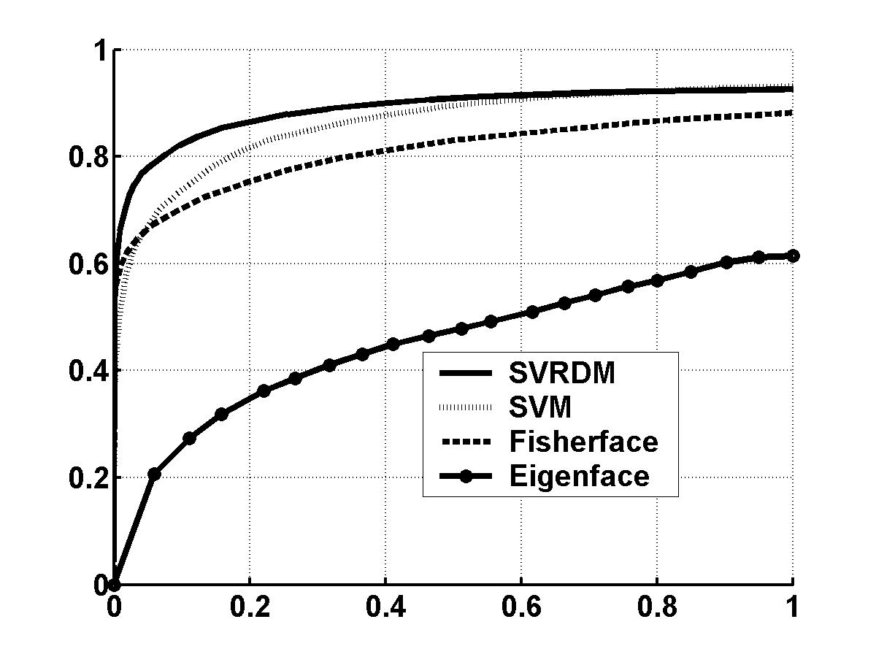
To address such training set issues, we consider only the K=40 class case and its SVRDFs. Initially, it gave an EER=15.0% and P_{HC}=92.6%. If we increase the number of illumination differences in the training set to 8 (illuminations 2, 4, 6, 8, 10, 12, 14 and 16), we find EER=11.7% and P_{HC}=95.8%. These are significant improvements. If we include all 13 poses in the training set (but only the original four illumination differences), we obtain very significant improvement to EER=4.2% and P_{HC}=98.9%. Thus, pose variations are much more significant than illumination variations. There was only one slack variable in the original test (K=40). There are zero and one slack variable in the last two cases, respectively. Thus, for example, a face image at poses 2 and 12 may seem very similar, but to a classifier they are quite different. In the original 2-step data, P_{C}=81.1% for input poses 10-13 and P_{C}=96.7% (illumination) for poses 1-9.
Fig.9 ROC curves for different classifiers using 40 object faces and 25 non-object faces

4.3 FACE VERIFICATION
In verification, the person states his identity and enters his facial image. If the match with the stated person is above some threshold T, the person is accepted; this contributes to the true acceptance rate (TAR) or P_{C} which is the fraction of all true test inputs N that were accepted. We wish to evaluate the usefulness of different classifiers for verification. In this case, we vary the output threshold T for the evaluation functions for the different classes for each classifier. In tests of non-object or imposter face inputs to be rejected, FAR or P_{FA} are (as before) the number of faces not rejected.
We use K=40 object faces and 25 non-object faces to be rejected with the same 9 poses and 4 illuminations used in the training set and with 273−36=237=N₁ test set inputs used per object class face and N₂=273 test inputs used for non-object test set inputs. All test set inputs are as before. Fig.10 shows ROC data P_{C} (or TAR) vs. P_{FA} (or FAR). At P_{FA}=0.1, the TAR rates are 98.5% (SVRDM), 96.0% (SVM), 90.7% (Fisherface), and 65.3% (Eigenface). The EER values are 4.0% (SVRDM), 6.0% (SVM), 10.0% (Fisherface) and 20.9% (Eigenface). Thus, the SVRDM performs best; the Eigenface processor performs worse.

SUMMARY

We presented test results for face recognition using the CMU PIE face database; both pose and illumination variations were considered. The classifiers investigated include the SVM, the SVRDM and two other classic methods: the Eigenface and Fisherface classifiers. We considered two strategies for this face rejection-classification problem. One approach used a view-based two-step strategy, in which the pose of a test input is first estimated and this is followed by an identity classification processor assuming the estimated pose. Our experimental results showed that the SVRDM performs best among all classifiers using the two-step strategy and that the SVRDM was less sensitive to the size of the classification problem than were other classifiers. Our results also note that it is necessary to include more pose and illumination variations in the training set, so that the training set is more representative of the test set. Furthermore, pose variations are found to be a more challenging problem than illumination variations. Our SVRDM was also shown to be applicable to the verification problem and it was shown to handle the unseen imposter case better than other classifiers do.
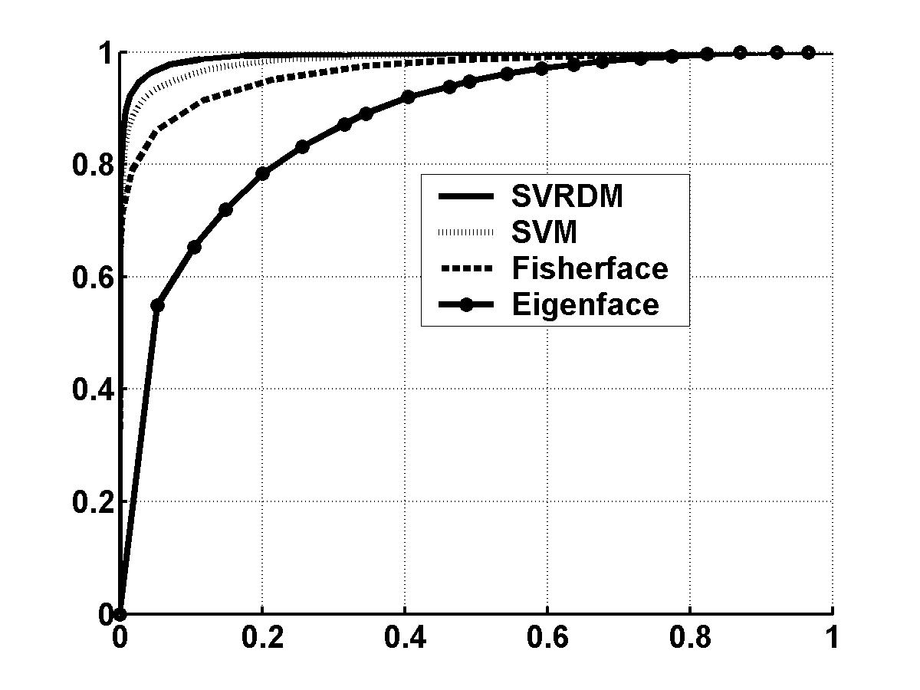
Fig.10 Verification ROC curves for different classifiers.

REFERENCES

[1] T. Sim, S. Baker and M. Bsat, “The CMU Pose, Illumination, and Expression (PIE) Database”, IEEE. Conf. on Automatic Face and Gesture Recog., May, 2002, pp.46-51.
[2] C. Yuan and D. Casassent, “Support Vector Machines for Class Representation and Discrimination”, Int’l Joint Conf. on Neural Networks, Portland, July, 2003.
[3] A. Pentland, B. Moghaddam and T. Starner, “View-Based and Modular Eigenspaces for Face Recognition”, CVPR, 1994.
[4] P. N. Belhumeur, J. P. Hespanha, and D. J. Kriegman, “Eigenfaces vs. Fisherfaces: Recognition Using Class Specific Linear Projection”, IEEE Trans. on PAMI, Vol.19, No.7, July, 1997, pp.711-720.
[5] R. Gross, I. Matthews and S. Baker, “Appearance-Based Face Recognition and Light-Fields”, CMU-RI-TR-02-20, Aug. 2002.
[6] A. S. Georghiades, P. N. Belhumeur and D. J. Kriegman, “From Few to Many: Illumination Cone Models for Face Recognition under Variable Lighting and Pose”, IEEE Trans. on PAMI, Vol.23, No.6, June, 2001, pp.643-660.
[7] V. Blanz, S. Romdhani and T. Vetter, “Face identification across different poses and illuminations with a 3D morphable model”, IEEE Conf. on Automatic Face and Gesture Recog. 2002, pp.192-197.
[8] R. Gross, J. Shi and J. F. Cohn, “Quo vadis Face Recognition”, Third Workshop on Empirical Evaluation Methods in Computer Vision, Dec. 2001.
[9] C.Cortes and V. Vapnik, “Support Vector Networks”, Machine Learning, 20, 1995, pp.273-297.
[10] C. J. C. Burges, “A Tutorial on Support Vector Machines for Pattern Recognition”, Data Mining and Knowledge Discovery, Vol.2, No.2, 1998, pp.121-167.
[11] Y. Q. Chen, X. S. Zhou and T. S. Huang, “One-Class SVM for Learning in Image Retrieval”, IEEE Conf. on Image Processing, 2001, pp.34-37.
[12] D. Tax and R. P. W. Duin, “Data Domain Description using Support Vectors”, Proc. of European Symposium on Artificial Neural Networks, 1999, pp.251-256.
[13] B. Scholkopf, R. C. Williamson, A. Smola and J. S. Tayler, “SV Estimation of a Distribution’s Support”, Advances in Neural Information Processing Systems 12, 2000, pp.582-588.
[14] K. Lam and H. Yan, “Locating and extracting the eye in human face images”, Pattern Recognition, Vol.29, No.5, pp.771-779, 1996.
[15] R. Chellappa, C. L. Wilson and S. Sirhey, “Human and Machine Recognition of Faces: a Survey”, Proceedings of the IEEE, Vol.83, No.5, 1995, pp.705-740.
[16] B. Moghaddam and A. Pentland, “Probabilistic Visual Learning for Object Representation”, IEEE Trans. on Pattern Analysis and Machine Intelligence, Vol.19, No.7, 1997, pp.696-710.

